Irrigation Structures Modules

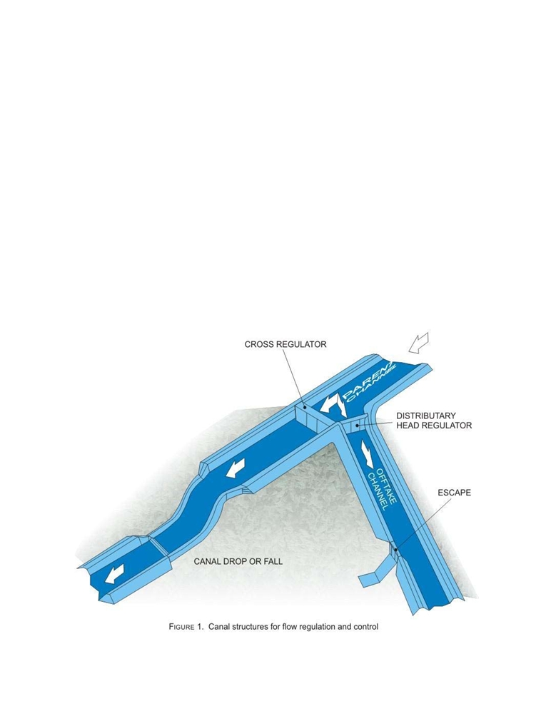

Instructional objectives
On completion of this lesson, the student shall be able to learn:

1. The necessity of providing regulating structures in canals.
2. The basics of canal drops and falls.
3. The importance of canal regulators.
4. The need for Groyne Walls, Curved Wings and Skimming Platforms.
5. The functions of escapes in a canal.

3.9.0 Introduction
A canal obtains its share of water from the pool behind a barrage through a structure called the canal head regulator. Though this is also a regulation structure for controlling the amount of water passing into the canal (with the help of adjustable gates), it shall be discussed under diversion works (Module 4). In this lesson, attention is focussed on structures that regulate the discharge and maintain the water levels within a canal network (Figure 1).

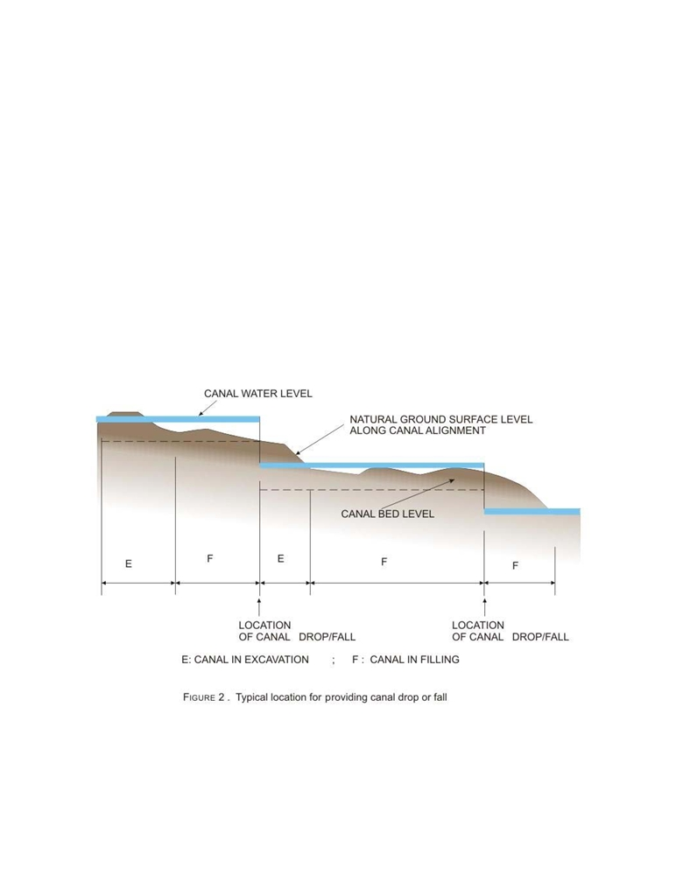

These structures may be described as follows:
1. Drops and falls to lower the water level of the canal
2. Cross regulators to head up water in the parent channel to divert some of it
through an off take channel, like a distributary.
3. Distributary head regulator to control the amount of water flowing in to off take
channel.
4. Escapes, to allow release of excess water from the canal system.

These structures are described in detail in this lesson.

3.9.1 Canal drops and falls
A canal has a designed longitudinal slope but has to pass through an undulating terrain. When a canal crosses an area that has a larger natural surface slope, a canal drop, also called fall in India, has to be provided suitably at certain intervals (Figure 2)

The location of a fall has to be judiciously worked out such that there should be a
balance between the quantities of excavation and filling. Further the height of the fall
has to be decided, since it is possible to provide larger falls at longer intervals or smaller
falls at shorter intervals. It may be observed that the portion of the canal which is
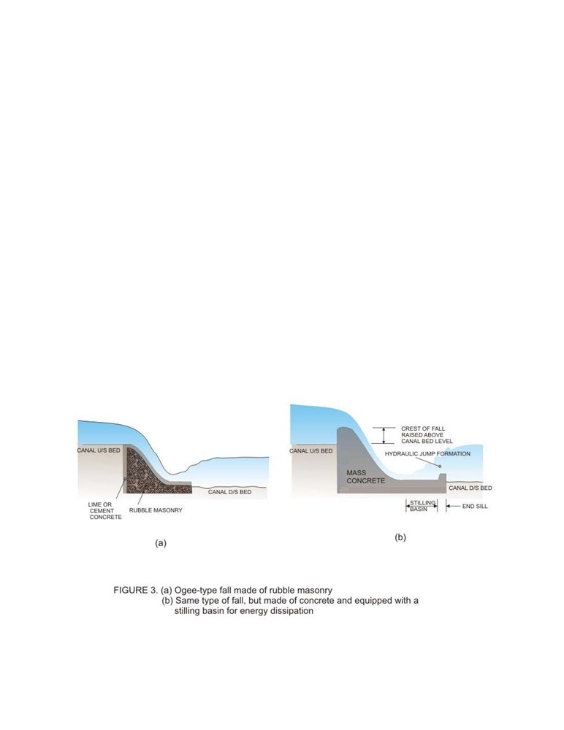

running in filling (Figure2) may be able to serve the surrounding area by releasing water by gravity. For the portion of the canal that is running in excavation, if surrounding areas have to be irrigated, it has to be done through pumping.

There are various types of fall structures, some of which are no more provided these
days. However, there are many irrigation projects in India which have these structures
in the canal network, as they were designed many years ago. Many of these structures
used boulder masonry as their construction material, whereas now brick masonry or,
more commonly, mass concrete is being used commonly in modern irrigation projects.

3.9.2 Falls of antiquity
The Ogee type of fall has been one of the first to be tried in the Indian canal irrigation
system, probably since more than a century back (Figure 3a). However, according to
the earliest structures provided, the crest of the fall was in the same elevation as that of
the upstream section of the canal. This caused a sharp draw-down of the water surface
on the upstream side. On the downstream, the drop in elevation added energy to the
falling water which exited the falls as a shooting flow, causing erosion of the canal bed
immediately downstream. These difficulties were later removed by raising the crest
level of the fall above the upstream canal bed level and providing suitable stilling basin
with end sill at the downstream end of the fall which kills most of the excess energy of
the leaving water by helping to form a hydraulic jump (Figure 3b).

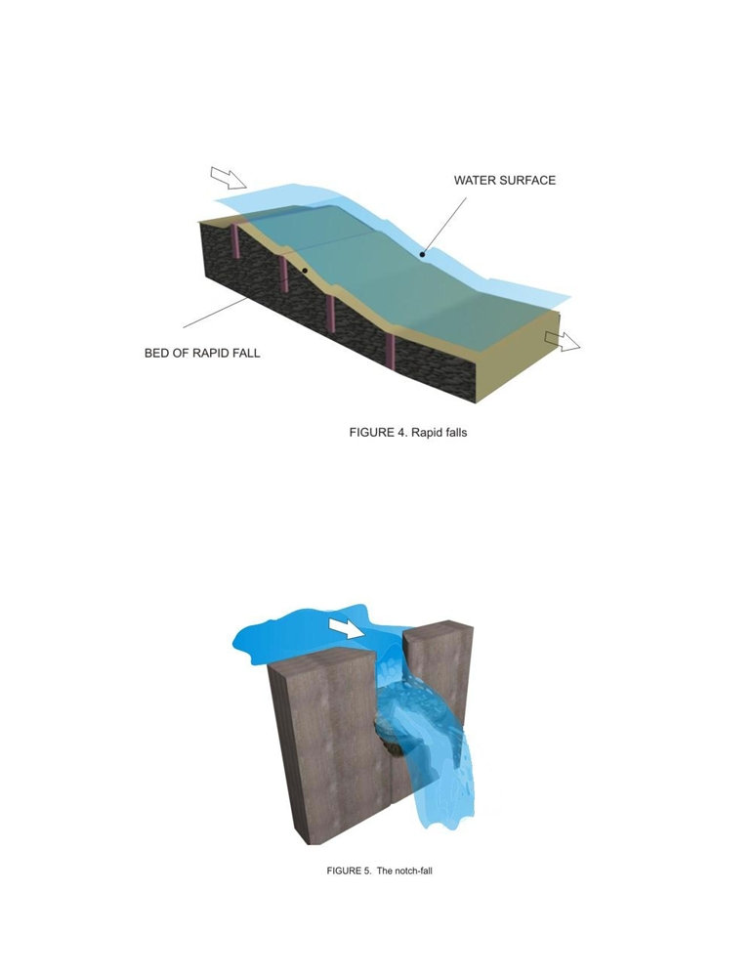

The rapid-fall was tried in some of the north-Indian canals which were constructed with boulders cemented together by lime concrete (Figure 4). These were quite effective but, the cost being prohibitive, was gradually phased out.

The trapezoidal-notch fall consists of one or more notches in a high crested wall across the channel with a smooth entrance and a flat circular lip projecting downstream from each notch to disperse water (Figure 5). This type of fall was started around the late nineteenth century and continued to be constructed due to its property of being able to maintain a constant depth-discharge relationship, until simpler and economical alternatives were designed.

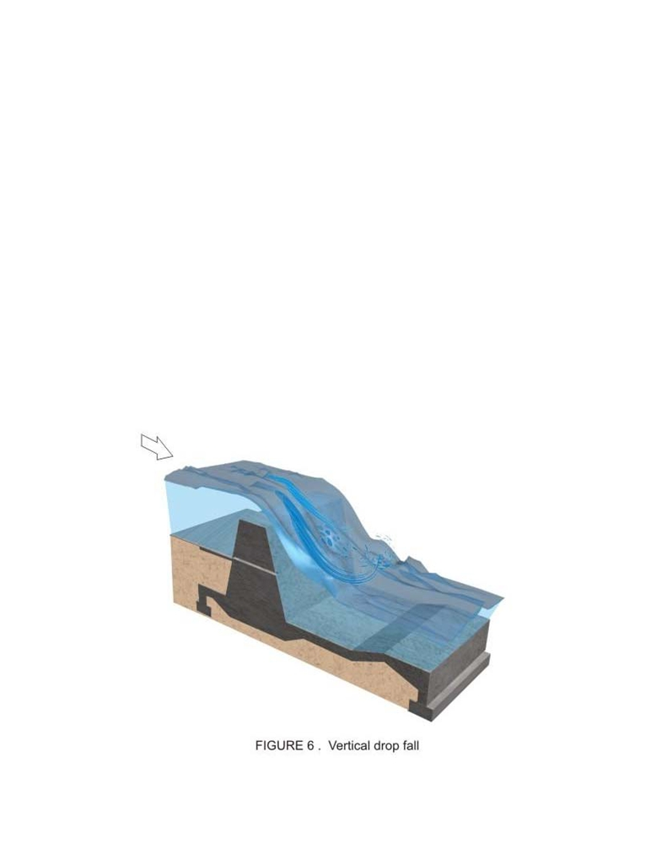

3.9.3 Modern falls
Some falls have been commonly used in the recent times in the canal systems of India. These are described in the following sections. Detailed references may be had from the following two publications of the Food and Agriculture Organisation (FAO):
1. FAO Irrigation and Drainage paper 26/1: Small Hydraulic Structures, Volume 1
(1982)
2. FAO Irrigation and Drainage paper 26/2: Small Hydraulic Structures, Volume 2
(1982)
These books are also available from the web-site of FAO under the title “Irrigation and Drainage Papers” at http://www.fao.org/ag/agL/public.stm#aglwbu.

3.9.3.1 Falls with vertical drop
These are falls with impact type energy dissipators. The vertical-drop fall (Figure 6) uses a raised crest to head up water on the upstream of the canal section and allows it to fall with an impact in a pool of water on a depressed floor which acts like a cushion to dissipate the excess energy of the fall. This type of fall was tried in the Sarda canal of Uttar Pradesh, which came to be commonly called as the Sarda-type fall.

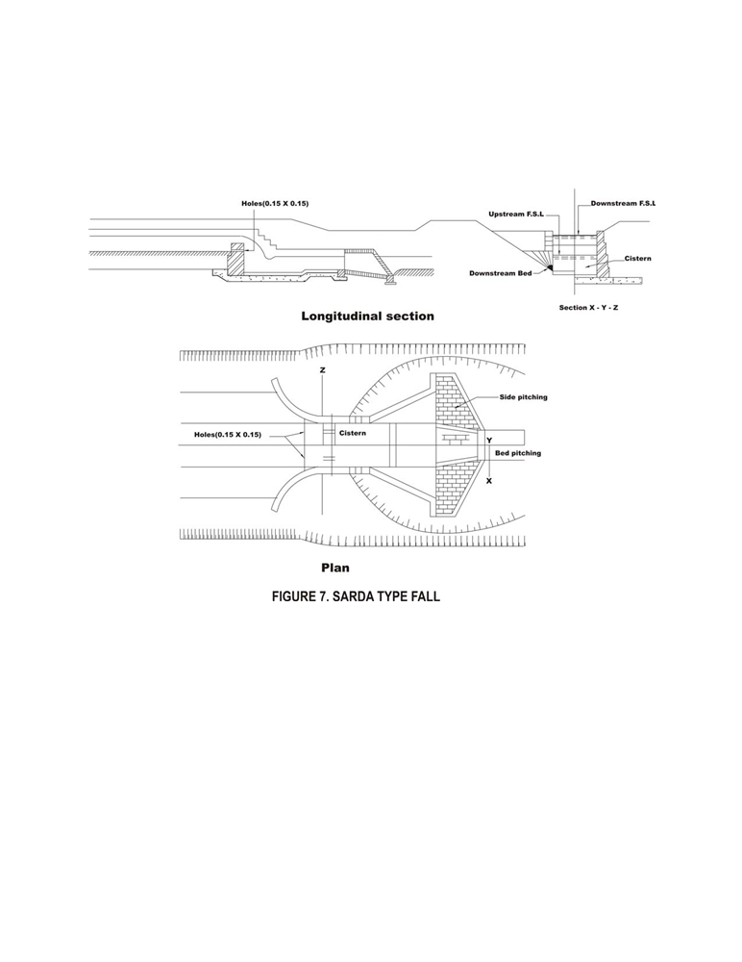

Typical plan and section of a Sarda-type fall is shown in Figure 7. Usually, two different
crests for the fall are adopted, as shown in Figure 8. For canals conveying discharges
less that 14m³/s, crest with rectangular cross section is adopted, and for discharges
more than that, trapezoidal crest with sloping upstream and downstream faces is
chosen.

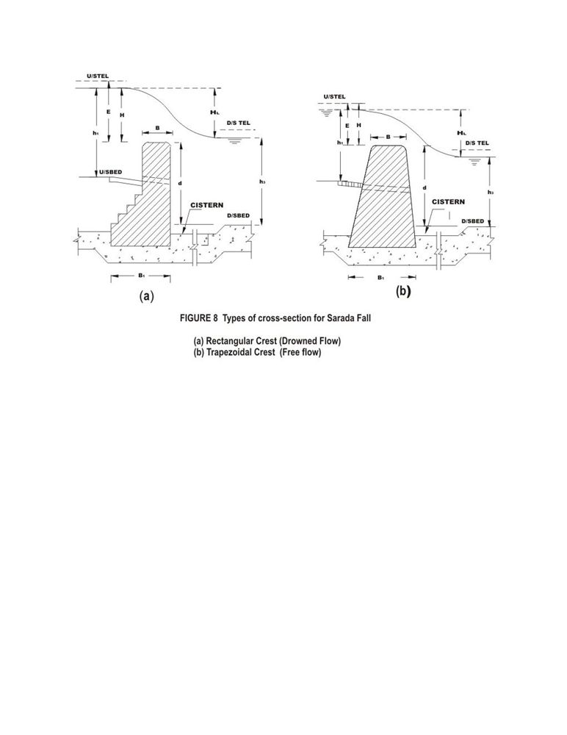

For smaller discharges, the following a may be provided.

• Well drop fall (Figure 9)
• Pipe drop fall (Figure 10)
• Baffled apron drop (Figure 11)

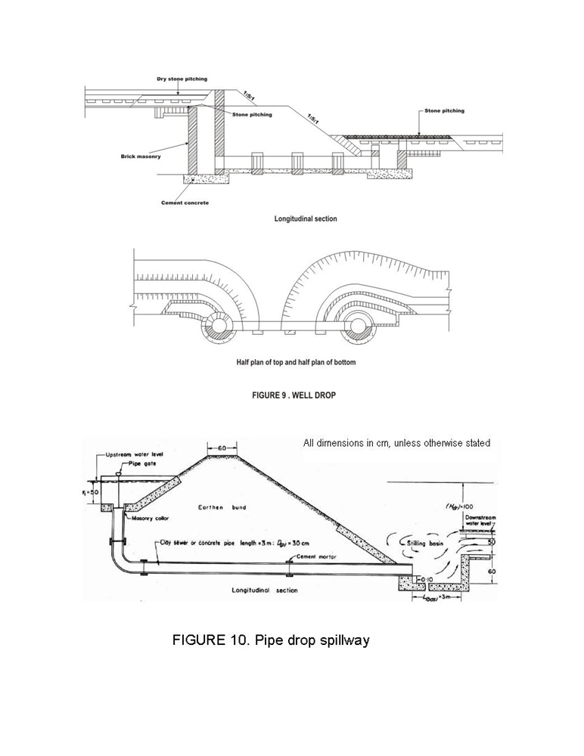

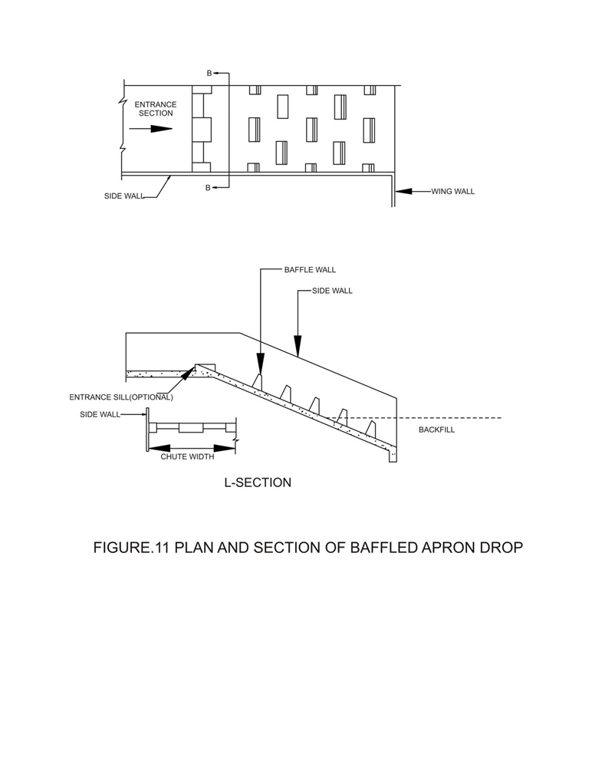

3.9.3.2 Falls with drop along inclined glacis
These are falls with and inclined glacis along which the water glides down and the energy is dissipated by the action of a hydraulic jump at the toe of the structure. Inclined drops are often designed to function as flume measuring devices. These may be with and without baffles as shown in Figures 12 and 13 respectively and supplemented by friction blocks and other energy dissipating devices (Figure 14).

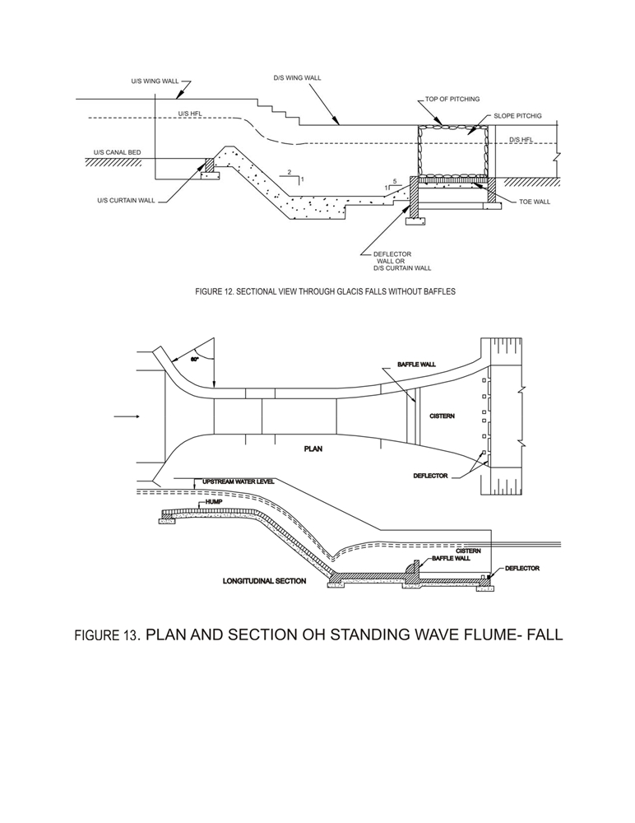

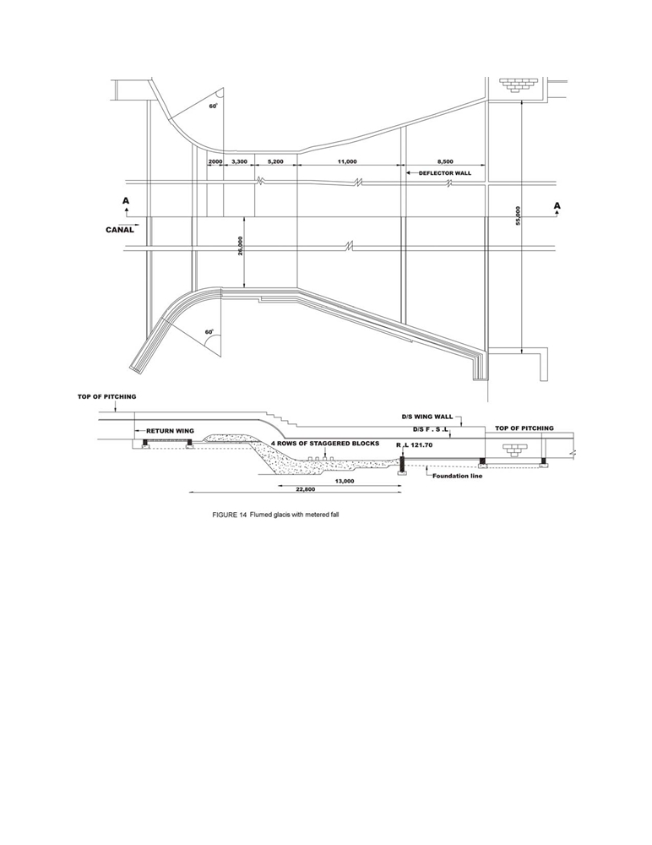

Similar type of fall was also developed in Punjab which was called the CDO type fall, as shown in Figure 15 (for hydraulic drop up to 1m) and Figure 16 (for hydraulic drop above 1m).

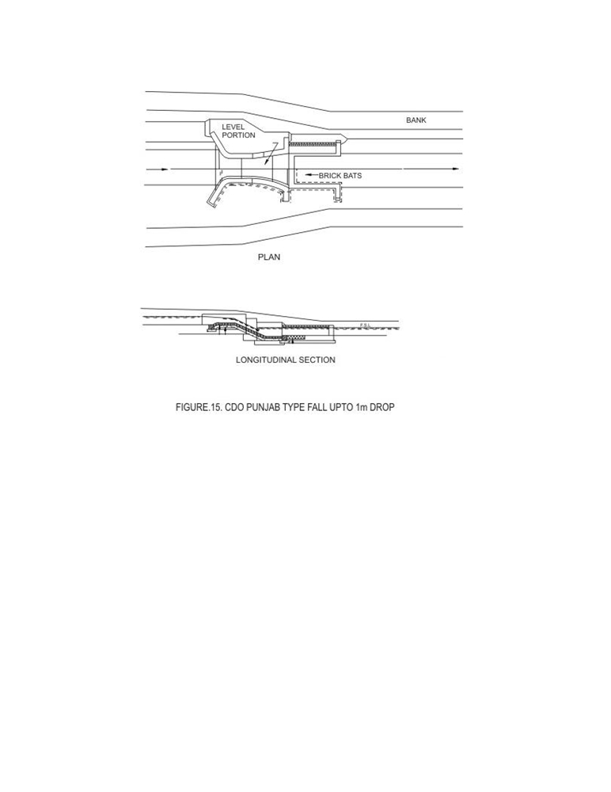

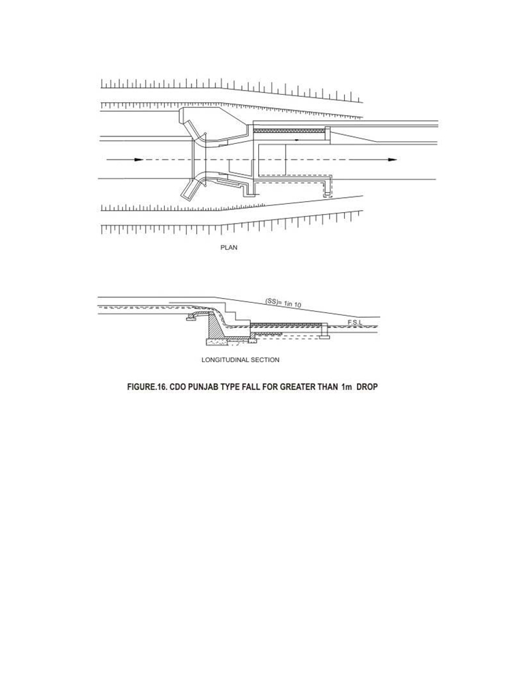

The glacis type falls may be modified in the following ways:

(a) Flumed or un-flumed, depending upon the crest width being smaller or equal to
the bed width of the canal (Figure17).

(b) Meter or non-meter fall depending upon whether the canal fall may be used to
measure the discharge as well. Details of a meter-fall is described in Lesson 3.10

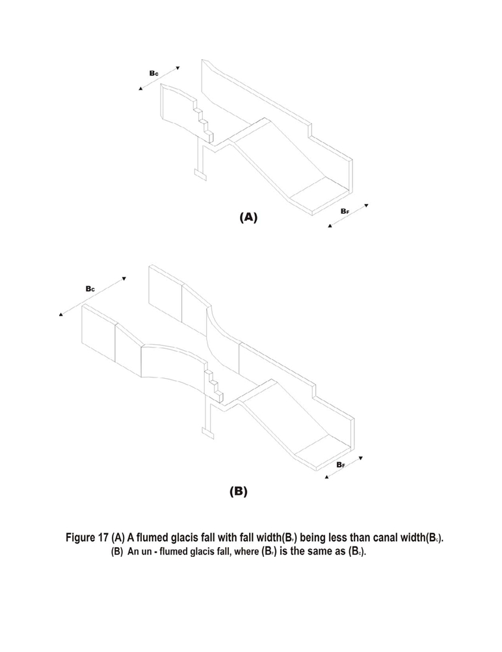

The following appurtenant structures should be considered while providing a verticaldrop or a glacis-type fall:

• The floor of the falls should be able to resist the uplift pressure under the
condition of dry canal and a high ground water table.
• Cut-off walls or curtain walls either of masonry or concrete should be provided
at the upstream and downstream ends of the floors of the falls.
• Bed protection with dry brick pitching should be provided in the canal just
upstream and downstream of the fall.
• Side protection should be provided at the upstream and downstream splays with
brick pitching.
Since falls are structures across a canal, it is usual for providing a bridge along with the fall structure for crossing the canal.

3.9.4 Canal regulators
These include the cross regulator and the distributary head regulator structures for controlling the flow through a parent canal and its off-taking distributary as shown in Figure 1. They also help to maintain the water level in the canal on the upstream of the regulator. Canal regulators, which are gated structures, may be combined with bridges and falls for economic and other considerations, like topography, etc.

A typical view of a distributary head regulator and a cross regulator (shown partly in section) is illustrated in Figure 18.

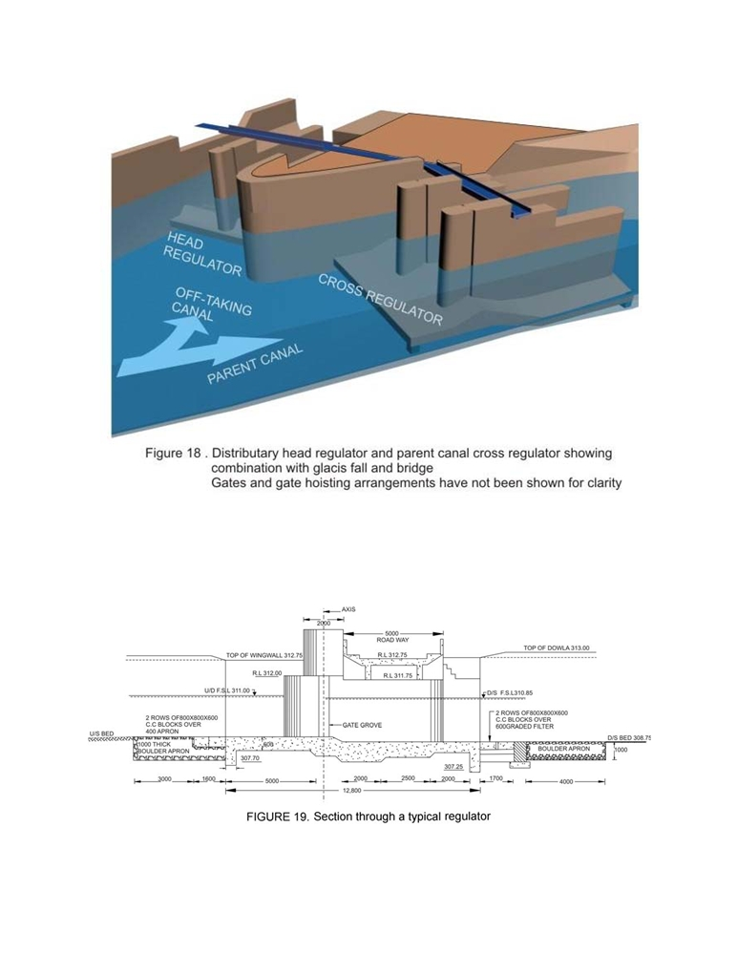

In the figure, the gates and gate hoisting arrangements have not been shown, for clarity. Further, the floor of the regulators would be protected on the upstream and downstream with concrete blocks and boulder apron. A typical sectional drawing through a regulator is shown in Figure 19.

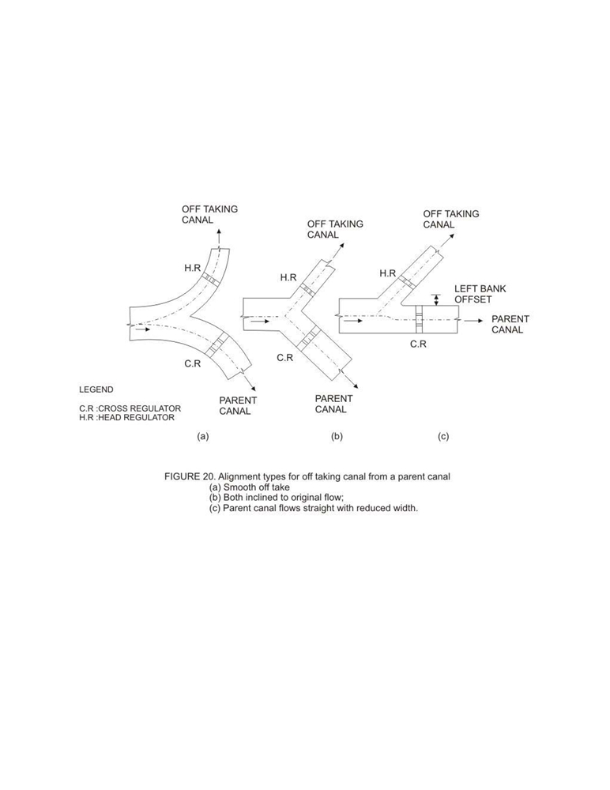

The angle at which a distributary canal off-takes from the parent canal has to be
decided carefully. The best angle is when the distributary takes off smoothly, as shown
in Figure 20(a). Another alternative is to provide both channels (off-taking and parent)
at an angle to the original direction of the parent canal (Figure 20b). When it becomes
necessary for the parent canal to follow a straight alignment, the edge of the canal
rather than the centre line should be considered in deciding the angle of off-take (Figure
20c).

To prevent excessive entry of silt deposition at the mouth of the off-take, the entry angle
should be kept to between 60⁰ and 80⁰. For the hydraulic designs of cross regulators,
one may refer to the Bureau of Indian Standard code IS: 7114-1973 “Criteria for
hydraulic design of cross regulators for canals”. The water entering in to the off-taking
distributary canal from the parent canal may also draw suspended sediment load.
The distributary should preferably be designed to draw sediment proportional to its flow, for maintaining non-siltation of either the parent canal or itself. For achieving this, three types of structures have been suggested as discussed below along with the relevant Bureau of Indian standard codes.

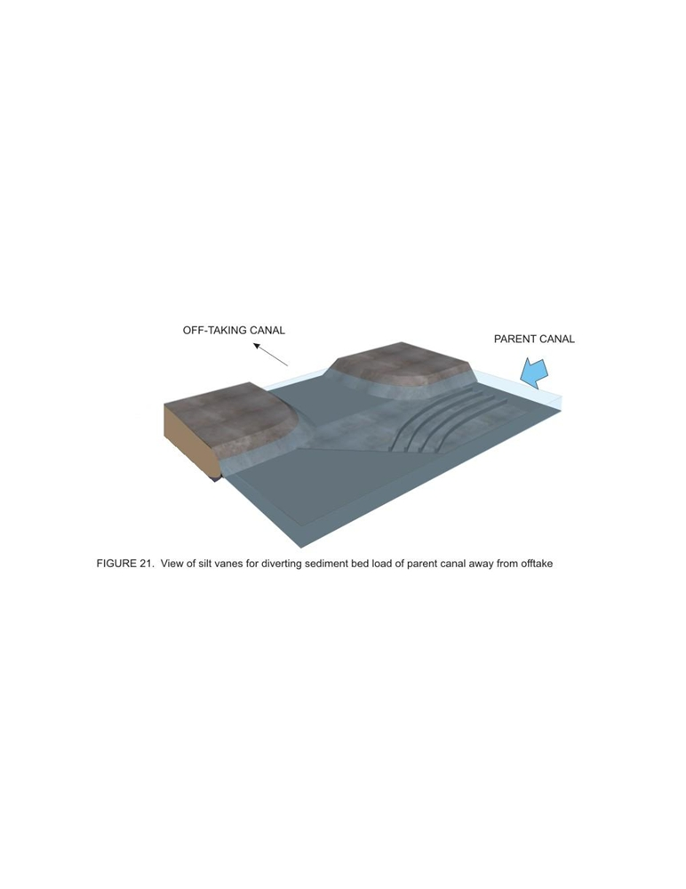

3.9.5 Silt vanes
(Please refer to IS: 6522-1972 “Criteria for design of silt vanes for sediment control in off-taking canals” for more details)

Silt vanes, or King’s vanes, are thin, vertical, curved parallel walled structures
constructed of plain or reinforced concrete on the floor of the parent canal, just
upstream of the off-taking canal. The height of the vanes may be about one-fourth to
one-third of the depth of flow in the parent canal. The thickness of the vanes should be
as small as possible and the spacing of the vanes may be kept about 1.5 times the vane
height. To minimize silting tendency, the pitched floor on which the vanes are built
should be about 0.15 m above the normal bed of the parent channel. A general three
dimensional view of the vanes is shown in Figure 21 and a typical plan and sectional
view in Figure 22.

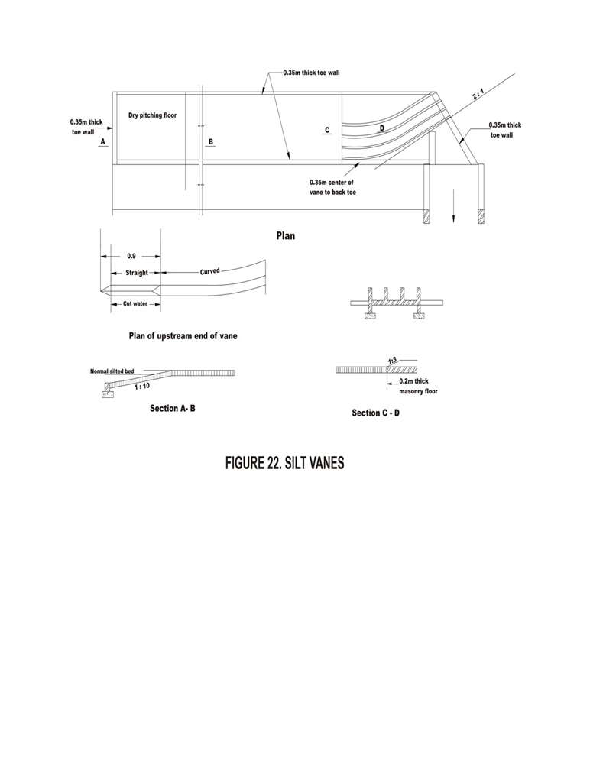

3.9.6 Groyne walls or curved wings
(Please refer to IS: 7871-1975 “Criteria for hydraulic design of groyne wall (curved wing) for sediment distribution at off-take points in a canal” for more details)

These are curved vertical walls, also called Gibb’s groyne walls, which project out in to the parent canal from the downstream abutment of the off-taking canal. The groyne wall is provided in such a way that it divides the discharge of the parent canal in proportion of the discharge requirement of the off-taking canal with respect to the flow in the downstream parent canal. The groyne wall extends upstream in to the parent canal to cover ¾ to full width of the off-take. The proportional distribution of flow in to the offtaking canal is expected to divert proportional amount of sediment, too. A general view of a groyne wall is shown in Figure 23.

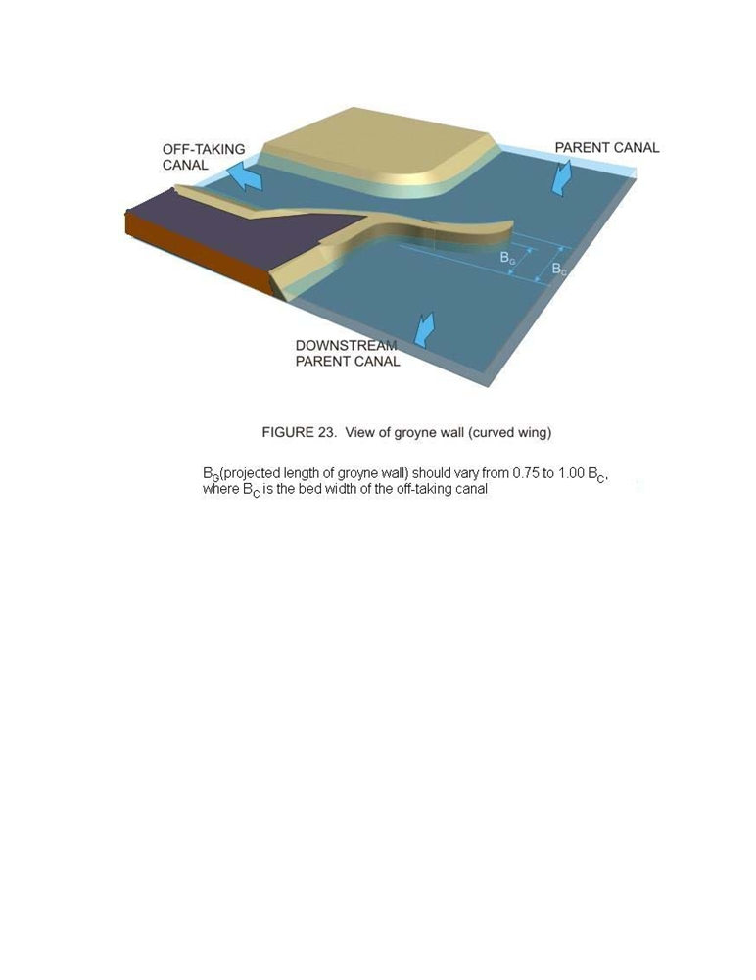

The distance of the nose from the upstream abutment of the off-take may be kept so as to direct adequate discharge in to the off-take. The height of the groyne wall should be at least 0.3m above the full supply level of the parent canal. At times, a combination of groyne wall and sediment vane may be provided.

3.9.7 Skimming platforms
(Please refer to IS: 7880-1975 “Criteria for hydraulic design of skimming platform for sediment control in off-taking canal” for more details).
A skimming platform is an RCC slab resting on low height piers on the bed of the parent canal, and in front of the off-taking canal, and in front of the off-taking canal as shown in Figure 24.

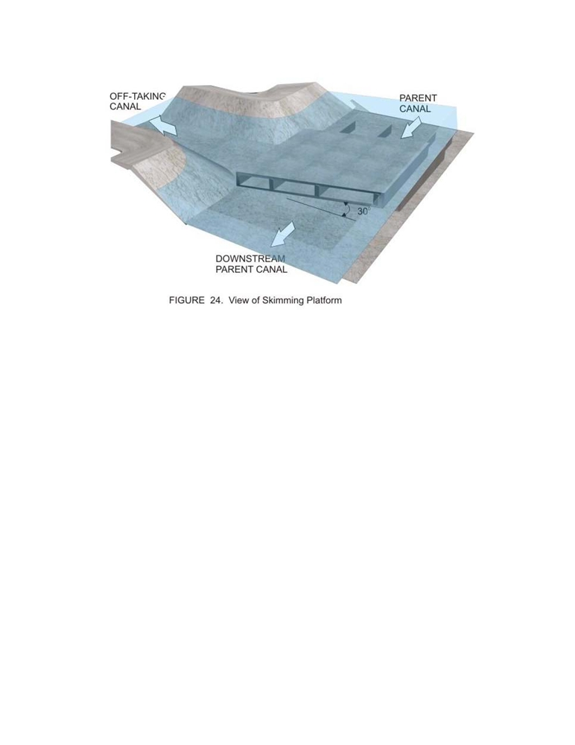

This arrangement actually creates a kind of low tunnel at the bed of the parent canal, which allows the sediment moving along its bed to pass through downstream. The floor of the off-taking canal being above the level of the platform thus only takes suspended sediment load coming along with the main flow in the parent canal. A skimming platform arrangement is suitable where the parent channel is deep (about 2m or more) and the off-take is comparatively small.
The tunnels should be at-least 0.6m deep. The upstream and downstream edges of the
platform should be inclined at about 30⁰ to the parent canal cross section. At times, silt
vanes can be combined with a skimming platform. In that case, the piers of the
platform are extended downstream in the form of vanes. A typical plan and section view of a skimming platform is shown in Figure 25.

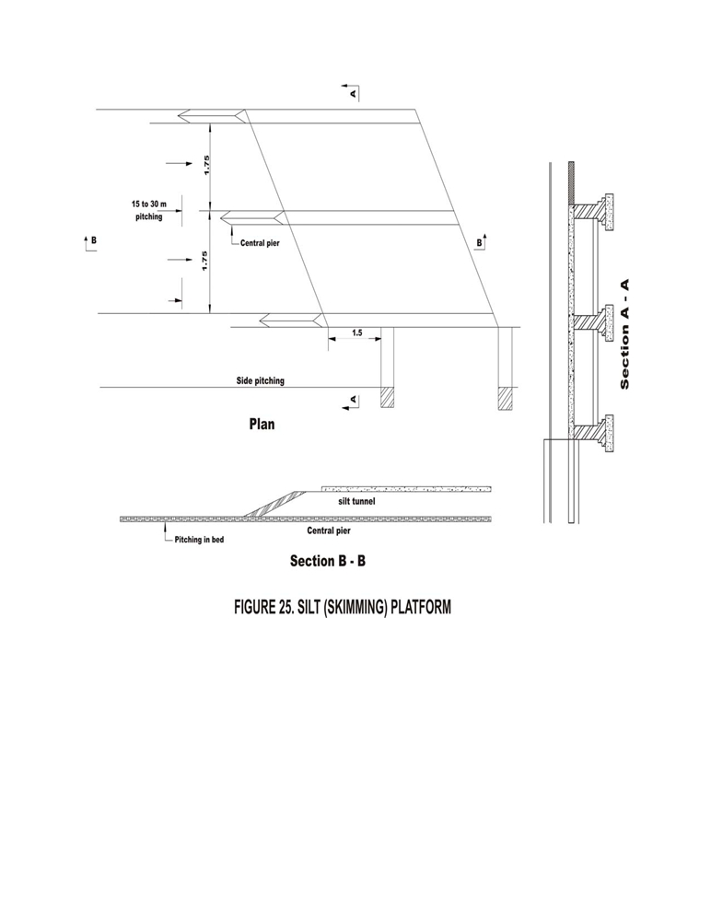

3.9.8 Canal escapes
These are structures meant to release excess water from a canal, which could be main canal, branch canal, distributary, minors etc. Though usually an irrigation system suffers from deficit supply in later years of its life, situations that might suddenly lead to accumulation of excess water in a certain reach of a canal network may occur due to the following reasons:

• Wrong operation of head works in trying to regulate flow in a long channel
resulting in release of excess water than the total demand in the canal system
downstream.
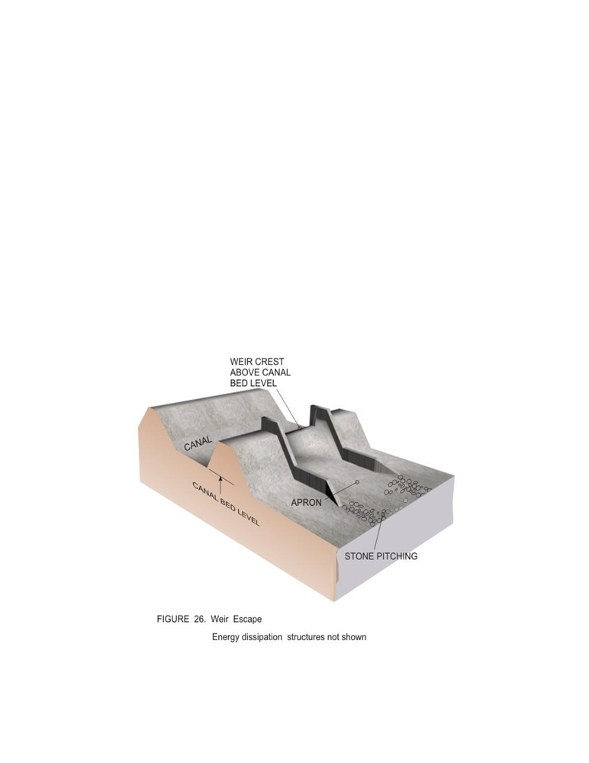

• Excessive rainfall in the command area leading to reduced demand and
consequent closure of downstream gates.
• Sudden closure of control gates due to a canal bank breach.
The excess water in a canal results in the water level rising above the full supply level which, if allowed to overtop the canal banks, may cause erosion and subsequent breaches. Hence, canal escapes help in releasing the excess water from a canal at times of emergency. Moreover, when a canal is required to be emptied for repair works, the water may be let off through the escapes.
Escapes as also built at the tail end of minors at the far ends of a canal network. These
are required to maintain the required full supply level at the tail end of the canal branch.

The construction feature of escapes allows it to be classified in to two types, as described below.

3.9.8.1 Weir or surface escapes
These are constructed in the form of weirs, without any gate or shutter (Figure 26) and spills over when the water level of the canal goes above its crest level

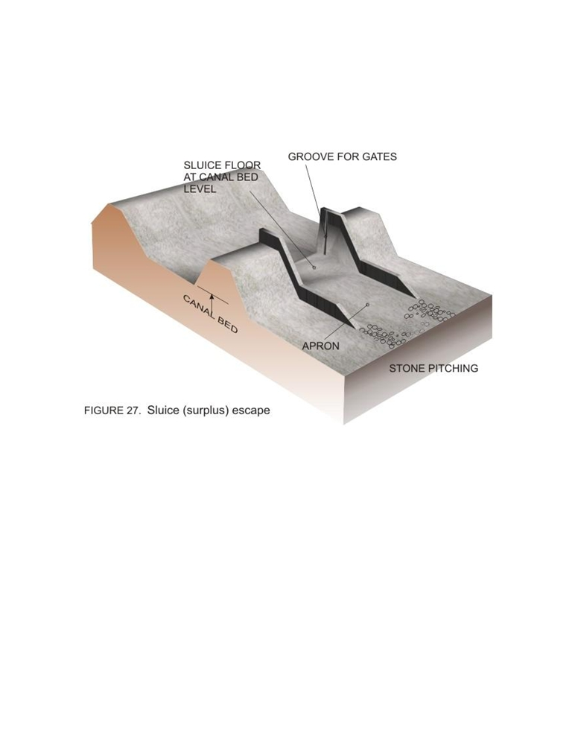

3.9.8.2 Sluice or surplus escapes
These are gated escapes with a very low crest height (Figure 27). Hence, these sluices can empty the canal much below its full supply level and at a very fast rate. In some cases, these escapes act as scouring sluices to facilitate removal of sediment.

The locations for providing escapes are often determined on the availability of suitable
drains, depressions or rivers with their bed level at or below the canal bed level so that
any surplus water may be released quickly disposed through these natural outlets.
Escapes may be necessary upstream of points where canals takeoff from a main canal
branch. Escape upstream of major aqueducts is usually provided. Canal escapes may
be provided at intervals of 15 to 20km for main canal and at 10 to 15km intervals for
other canals.
The capacity of an escape channel should be large enough to carry maximum escape discharge. These should be proper energy dissipation arrangements to later for all flow conditions. The structural and hydraulic design would be similar to that of regulators or sluices or weirs, as appropriate.
The Bureau of Indian Standards code IS 6936:1992 (reaffirmed 1998) “Guide for
location, selection and hydraulic design of canal escapes” may be referred to for further
details.

References

• FAO Irrigation and Drainage paper 26/1: Small Hydraulic Structures, Volume 1
(1982)
• FAO Irrigation and Drainage paper 26/2: Small Hydraulic Structures, Volume 2
(1982)
• Garg, S K (1996) “Irrigation engineering and hydraulic structures”, Twelfth Edition,
Khanna Publishers
• IS 4410 : Part 15 : Sec 4 : 1977 Glossary of terms relating to river valley projects:
Part 15 Canal structures Section 4 Regulating works
• IS 6522 : 1972 Criteria for design of silt vanes for sediment control in offtaking
canals
• IS 6531 : 1994 Canal Head Regulators - Criteria for Design
• IS 6936 : 1992 Guide for location, selection and hydraulic design of canal escapes
• IS 7114 : 1973 Criteria for hydraulic design of cross regulators for canals
• IS 7495 : 1974 Criteria for hydraulic design of silt selective head regulator for
sediment control in offtaking canals
• IS 7880 : 1975 Criteria for hydraulic design of skimming platform for sediment
control in offtaking canal
• IS: 6936-1992 (reaffirmed 1998) “Guide for location, selection and hydraulic design
of canal escapes”
• IS: 7114-1973 “Criteria for hydraulic design of cross regulators for canals”
• Varshney, R S, Gupta, S C and Gupta, R L (1993) “Theory and design of irrigation
structures”, Volume II, Sixth Edition, Nem Chand Publication

